**Project Design Phase-II**

**Data Flow Diagram & User Stories**

|  |  |
| --- | --- |
| Date | 03 October 2022 |
| Team ID | PNT2022TMID39315 |
| Project Name | Project – Nutrition Assistant Application |
| Maximum Marks | 4 Marks |

**Data Flow Diagrams:**

A Data Flow Diagram (DFD) is a traditional visual representation of the information flows within a system. A neat and clear DFD can depict the right amount of the system requirement graphically. It shows how data enters and leaves the system, what changes the information, and where data is stored.

DFA (Data Flow Diagram)

**Example:** [**(Simplified)**](https://developer.ibm.com/patterns/visualize-unstructured-text/)

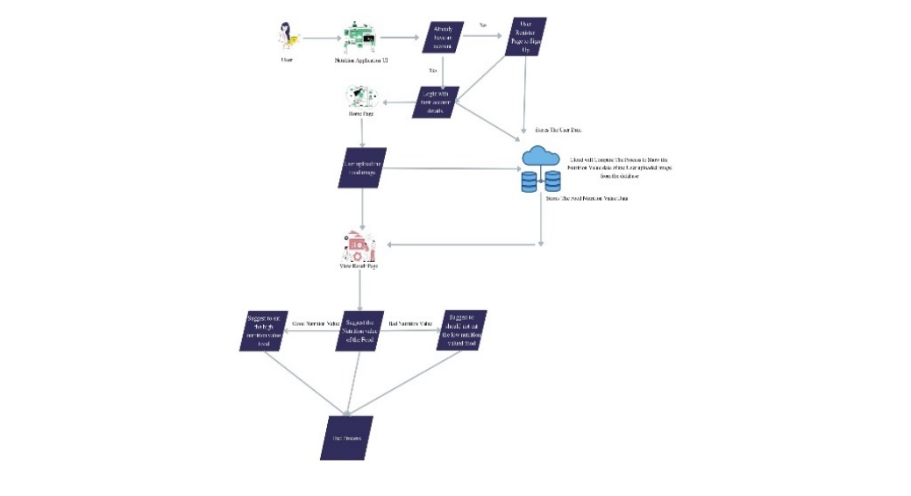

Upload the food image

Values view page

Get the nutrition and calorie value

Predict the image and computing

User Interface

Register

Login

User

**User Stories**

Use the below template to list all the user stories for the product.

| **User Type** | **Functional Requirement (Epic)** | **User Story Number** | **User Story / Task** | **Acceptance criteria** | **Priority** | **Release** |
| --- | --- | --- | --- | --- | --- | --- |
| Customer (Mobile user) | Registration | USN-1 | As a user, I can register for the application by entering my email, password, and confirming my password. | I can access my account / dashboard | High | Sprint-1 |
|  |  | USN-2 | As a user, I will receive confirmation email once I have registered for the application | I can receive confirmation email & click confirm | High | Sprint-1 |
|  |  | USN-3 | As a user, I can register for the application through Facebook | I can register & access the dashboard with Facebook Login | Low | Sprint-2 |
|  |  | USN-4 | As a user, I can register for the application through Gmail |  | Medium | Sprint-1 |
|  | Login | USN-5 | As a user, I can log into the application by entering email & password |  | High | Sprint-1 |
|  | Dashboard | USN-6 | User get into the dashboard and see’s the different web pages to compute what the user needs. |  | High | Sprint-1 |
| Customer (Web user) | Registration | USN-7 | As a user, I can register the form with username, Emil-id and password. | I can register and able to access the account. | High | Sprint-1 |
|  |  | USN-8 | As a user, I can register with my google mail-id and password. | I can register & get an access to use the dashboard. | High | Sprint-1 |
|  | Login | USN-9 | As a user, I can login to the application by entering my mail and password |  | High | Sprint-1 |
|  | Dashboard | USN-10 | User get into the dashboard and see’s the different web pages to compute what the user needs. |  | High | Sprint-1 |
| Customer Care Executive | FAQ | USN-11 | As a user you’ll ask query or doubt about the application to the admin side. As per protocols the user will get the response from the admin. |  | Medium | Sprint-3 |
| Administrator | Register & login page | USN-12 |  |  |  |  |
|  | Register page | USN-12(I) | If the user is new to the application admin here to ask the user to sign up first or to fill the register the form from the user to get the user details. | If every thing is acceptable the user will access the Dashboard. | High | Sprint-1 |
|  | Login page | USN-12(II) | If the user already registered the admin will get the data and user will login to application by entering email and password where the data are already stored in the database. | User get access to use the Dashboard | High | Sprint-1 |
|  | Database process |  |  |  |  |  |
|  | Add food data and user data to the database | USN-13 | 1. Admin will store the food nutrition value and calories value of the primary taken foods and fast foods. 2. Admin will customize a code to store the user data to the database from the registration page. |  | High | Sprint-2 |
|  | User Interface |  |  |  |  |  |
|  | Upload the food image and get the prediction | USN-14 | Here the user will upload the picture from the files to web page upload the picture, for get to know about the nutrition value. here the computation process as to predict the food image and to get the food values from the database. | If the picture is clear, able to predict and goes to the next stage. | High | Sprint-3 |
|  | Get the calories and nutrition value form the food item | USN-15 | Admin will compute the process over cloud to get the correct food value for the predicted image that user uploaded |  | High | Sprint-4 |